Traffic monitoring from space for sustainable development of the road network

S. Ø. Larsen ^{a,}*, M. Aldrinª, O. Haugª, A. Salbergª, R. Solberg ª, K.Gryteselv ^{b}, K.Johansen ^{b}

ª Norwegian Computing Center, P.O.Box 114 Blindern, NO-0314 Oslo, Norway – (siri.larsen, magne.aldrin, ola.haug, arnt-borre.salberg, rune.solberg)@nr.no
^{b} The Norwegian Public Roads Administration, P.O.Box 4142 Dep, NO-0033 Oslo, Norway – (kristin.gryteselv, kjell.johansen)@vegvesen.no

Abstract – Road traffic greatly affects the environment. Advanced traffic monitoring may improve planning, construction, and maintenance of road networks, and thus contribute to a reduction of pollution and noise. Information about traffic density can be used to model the amount of air pollution and noise. We have developed image analysis methodology based on pattern recognition for automatic vehicle detection, and have demonstrated this approach for a number of test scenes in Norway using QuickBird data. In order to predict useful traffic densities over time, we apply the basis curve method. This method predicts the annual traffic volume for sites where counts are available for a limited time of the year only. Our experiments indicate that the suggested approach is feasible. The detection rate is 92% and the false alarm rate is 11%.

Keywords: Vehicle detection, road traffic density, high resolution optical satellite imagery, image analysis, basis curve method, air pollution.

- INTRODUCTION

Road networks are essential resources in modern transportation infrastructure that requires careful planning. Inevitably, road traffic leads to air pollution and noise, which is harmful to people and our environment in general in many ways. The Norwegian Public Road Administration (NPRA) is responsible for 90,000 km of public roads. Their work relies on information about the current traffic density and forecasts for the future traffic situation. The level of pollution and noise is estimated by models that depend on traffic density as main input parameter. The traffic density is currently measured at 9,300 counting stations throughout the Norwegian road network, but is far from satisfactory when it comes to geographical coverage. Due to limitations on equipment and operational costs, the resolution with regard to vehicle (weight) classes is also less than desired, and so is the time resolution.

Very high resolution satellite images allow automated monitoring of the road traffic situation. Although the time resolution of useful satellite image series may be inadequate, this approach can offer immense improvements when it comes to geographical coverage.

Extensive research has been performed on vehicle detection in aerial imagery, (e.g., Burlina et al., 1997; Hinz, 2005; Schlosser et al., 2003; Zhao and Nevatia, 2001). Recently, some research groups have also started to address vehicle detection in very high

resolution satellite images, (e.g., Sharma et al., 2006; Jin and Davis, 2007; Zheng and Li, 2007). Common to all previous research we have knowledge about is that the methods have been developed for US highways or roads in large urban environments around the world. Our research focuses on the difficulties related to analysis under Norwegian conditions. Norway is a sparsely populated country, and roads are typically narrow and often close to a forest on one or both sides of the road. Thus a frequently encountered problem is that much of the road is hidden by tree shadows. Furthermore, the traffic density is very low compared to published studies from highways in other countries.

Our primary objective is to develop an automated approach for robust detection of vehicles in very high resolution satellite imagery of Norwegian roads. Secondly, we investigate the quality of traffic density estimates based on timely sparse data, i.e., data designed to simulate traffic counts from satellite data, using the basis curve method. Compared to Larsen et al. (2008), detection results have been improved by addressing some of the previously encountered challenges, such as the need for more localized segmentation, and a different classification strategy.

- DETECTION METHODS

  - Data
The image data consists of five QuickBird satellite images of 0.6m ground resolution in the panchromatic band. Road masks are applied to the images in order to restrict vehicle detection to roads. The road masks were manually constructed for this study. Table 1 presents an overview of the data used in the experiments. The extracted roads represent typical Norwegian traffic conditions, i.e., narrow two-lane roads, relatively low traffic density, and challenging conditions related to tree shadows covering parts of the road surface.

  - Detection methods
The segmentation step is based on Otsu’s method for automatic threshold selection (Otsu, 1979). However, instead of considering the whole image when the threshold is selected, we focus on a small region of the road at the time. This is necessary since we will perform detection in a large area (several kilometers of road), and the local illumination conditions can vary greatly from one location to the other within the same image. Furthermore, the local conditions on the road will usually differ throughout the image, due to variations in road surface conditions, road markings, asphalt color, etc.

Table 1. Experimental data.

Location | Date | Tot. length of road segments (km) | Number of vehicles | Vehicle density (vehicles per km) | Site no.
Østerdalen | Aug 10 2004 | 31,4 | 42 | 1,3 | 1-16
Kristiansund | Jun 19 2004 | 5,8 | 32 | 5,5 | 17-21
Kristiansund | Jul 8 2008 | 12,4 | 46 | 3,7 | 22-29
Sollihøgda | May 10 2002 | 3,1 | 9 | 2,9 | 30
Sollihøgda | Aug 21 2008 | 3,1 | 25 | 8,1 | 31

Before thresholding, we perform morphological operations that enhance the visibility of the vehicles. More specifically, we perform gray tone dilation with a structuring element that represents a line, oriented in the same direction as the road, to enhance bright vehicles. Similarly, we perform gray tone erosion to enhance dark vehicles. We then traverse the road along the midline, extract sub images that represent ~20m road segments, and assume that the direction of the road is constant within a sub image. We calculate the Otsu threshold for the dilation and erosion results separately. If the separation between the classes exceeds a preset limit, we binarize the image using the Otsu threshold, extract the foreground segments, and calculate a number of features for each segment. Three shadow segments are excluded by rejecting segments that extend outside the road mask. See Figure 1 for some segmentation examples.

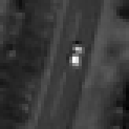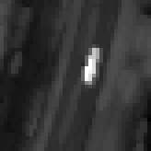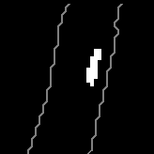

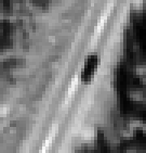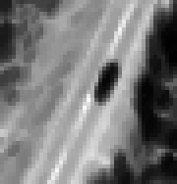

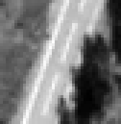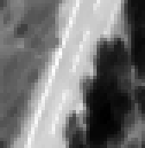

Figure 1. The segmentation process. The rows show three cases of segmentation. Left column: panchromatic image. Middle column: dilated (upper row) and eroded (middle and lower row) images. Right column: segmentation results. The contour of the road mask is overlaid on the segmentation result.
The extracted features include both radiometric (e.g., mean intensity) and spatial (e.g., area, elongation) properties of the segments, as well as context based features, such as the position of the segment relative to the midline and the edges of the road. Classification is performed on bright and dark segments separately. We use a k-nearest-neighbour classifier (5-KNNC), with two classes - vehicle and non-vehicle. Prior to classification, the mean of the feature space is shifted to the origin, and the features are scaled to unit total variance, neglecting class relationships.

  - Results
The methods were tested on a total of 31 sub images, each containing a road segment of roughly 1-3 km (Table 1). For classification, testing was performed at the sub images, one at the time, leaving the segments from the relevant sub image out of the training set (leave-one-out approach).

The number of vehicles in Table 1 corresponds to the number of vehicles that are apparent in the image and found by manual inspection. The segmentation result was manually inspected and compared to the marked vehicle positions. Based on this inspection we found that 94% of the vehicles were satisfactorily segmented, i.e., 6% were either lost during segmentation, or combined with a non-vehicle object into a joint segment. The total number of segmented objects was approximately eight times that of the total number of vehicles.

All segments were manually labeled as vehicle or non-vehicle. Segments that represent vehicle shadows were considered to belong to the vehicle class, as they share similar geometrical and spectral properties as dark vehicle segments. The classification error was 1.90% for bright segments and 6.28% for dark segments.

More interesting results are found by looking at the number of vehicles reported as detections by the final algorithm, and the frequency of false alarms. Since a bright vehicle may be represented by a bright and/or a dark segment (the vehicle shadow), the classification output images must be inspected. More specifically, the final result image is constructed by adding the bright and dark segments classified as vehicles, and counting the number of final vehicle segments. To ensure that bright vehicles are not counted twice (the vehicle segment and its shadow), bright segments are dilated in the direction of the expected shadow, i.e., given the known position of the sun in the sky at the moment of image acquisition, in order to ensure overlap of the segments. The final detection results are given in Table 2. The detection rate (the fraction of vehicles that are detected) is 92.2%, while the false detection rate (the number of false alarms divided by the number of vehicles) is 11.0%.

As seen in Table 2, the detection rates vary with the location of the road segments. Site 23 is an outlier with 9 false alarms. This and other sub images from the Kristiansund image (Table 1), contain more clutter than the images from the other locations. The false alarms are almost exclusively due to small parts of tree shadows. The two exceptions include a truck, whose two trailer wagons have been counted as separate vehicles, and a bright road marking. The missing detections are usually due to segmentation - nine out of 154 vehicles are lost during segmentation, and another three vehicles are lost during classification.

Table 2. Final detection results.

Site no. | No. of vehicles | No. of detected vehicles | No. of false alarms
1 | 2 | 2 | 1
2 | 7 | 7 | 0
3 | 1 | 0 | 2
4 | 2 | 2 | 0
5 | 2 | 1 | 0
6 | 2 | 2 | 0
7 | 3 | 3 | 0
8 | 3 | 3 | 0
9 | 2 | 2 | 0
10 | 2 | 2 | 0
11 | 2 | 2 | 0
12 | 3 | 3 | 1
13 | 3 | 3 | 0
14 | 4 | 4 | 2
15 | 2 | 1 | 0
16 | 3 | 2 | 0
17 | 2 | 2 | 0
18 | 1 | 1 | 0
19 | 6 | 4 | 0
20 | 9 | 8 | 0
21 | 14 | 12 | 1
22 | 6 | 6 | 0
23 | 11 | 10 | 9
24 | 8 | 8 | 0
25 | 10 | 8 | 0
26 | 3 | 3 | 0
27 | 1 | 1 | 0
28 | 4 | 4 | 0
29 | 2 | 2 | 0
30 | 9 | 9 | 0
31 | 25 | 25 | 1
tot. | 154 | 142 | 17

- THE BASIS CURVE METHOD

  - Prediction of traffic volume
The models for air pollution and noise used by the NPRA require prediction of Annual Average Daily Traffic (AADT), which is the average number of vehicles that pass a given road during one day. Usually, traffic counts are available for only parts of the year, thus AADT must be estimated, e.g., using the basis curve method (Aldrin, 1998). The method is based on fitting a set of predefined basis curves, which describes the trend variation in traffic volume, to the available data, and supplies the precision of the traffic volume estimates as a function of the sampling design, i.e., when and for how long the traffic is counted.

Assuming satellite data may be used for reliable traffic counts, there would still be a very restricted amount of data available for input to the basis curve method. Detection of vehicles from space requires very high resolution imagery, taken from a rather blue sky, preferably during the snow free season of the year. The solar elevation also affects the quality of the images. With the commercial satellites of today, this means that we could expect from one to a few useful images per year. One image covering a five kilometer road section where the average speed is 60 kilometers per hour could hold the information equivalent to five minutes of in-road counting (i.e., a single point in the road). The question now is whether a few counts of only a few minutes each is sufficient for the basis curve method to make an acceptable estimate of AADT.

  - Data and experiments
Traffic counts of five minutes time resolution was collected by the NPRA from a set of traffic stations, together with continuous hourly traffic counts throughout the year. We used the hourly counts to estimate the reference, or “true”, AADT, while the five minute data was used to construct data sets that were meant to represent different combinations of counts one would expect to obtain from satellite data from within one year. We then used these data sets one by one to estimate AADT, and compared the results to the true AADT.

More specifically, we assume it is likely to obtain between one and six useful images per year, and that each image gives the equivalent information of five to 15 minutes of single-point (traditional) measurements. Hence, the experiments include from one up to six counts, and with one, two, or three contiguous five minute intervals per count, i.e., with duration five, ten, or 15 minutes. With an average vehicle speed of 80 km/h, this corresponds to road segments of length 6.7 km, 13.3 km, and 20 km, respectively. For each combination of counts, the counting intervals are randomly drawn from the pool of useful intervals, until we get a useful data set. We construct 1000 data sets in this manner, and then use each data set to make an AADT estimate.

We define three traffic volume classes; small (<10,000), medium (10,000-20,000), and large (>20,000) AADT. The experimental data include five roads with small AADT, eight roads with medium AADT, and five roads with large AADT. Unfortunately, no road in our data set has AADT less than around 2000.

  - Results
The results (Figure 2) show some clear trends. First of all, the error is smaller the more counts that are used in the AADT estimate, and the error is also smaller when each count represents a longer time interval (e.g. 15 minutes) than a shorter time interval (e.g. 5 minutes). Secondly, comparing the error between the classes, the results are worst for counting stations with small AADT, and then get increasingly better for counting stations with medium to large AADT.

With three five minute counts or more, the average absolute error is roughly 20% in our case. It should be noted that the error may be larger for individual counting stations, and the error will also most likely be larger if we include roads with even less traffic (say, AADT < 1000).

The results also indicate that the smaller the AADT, the more there is to gain on adding more counts. This can be seen as the error curves, as expected, are steeper for smaller AADT than for larger. However, using six counts, the absolute error measures around 15-17%, no matter which AADT class we are looking at. It is surprising that the curve is more or less flat above three counts in the large AADT case. This may be explained by contingencies in the data. The amount of experimental data is limited, with only
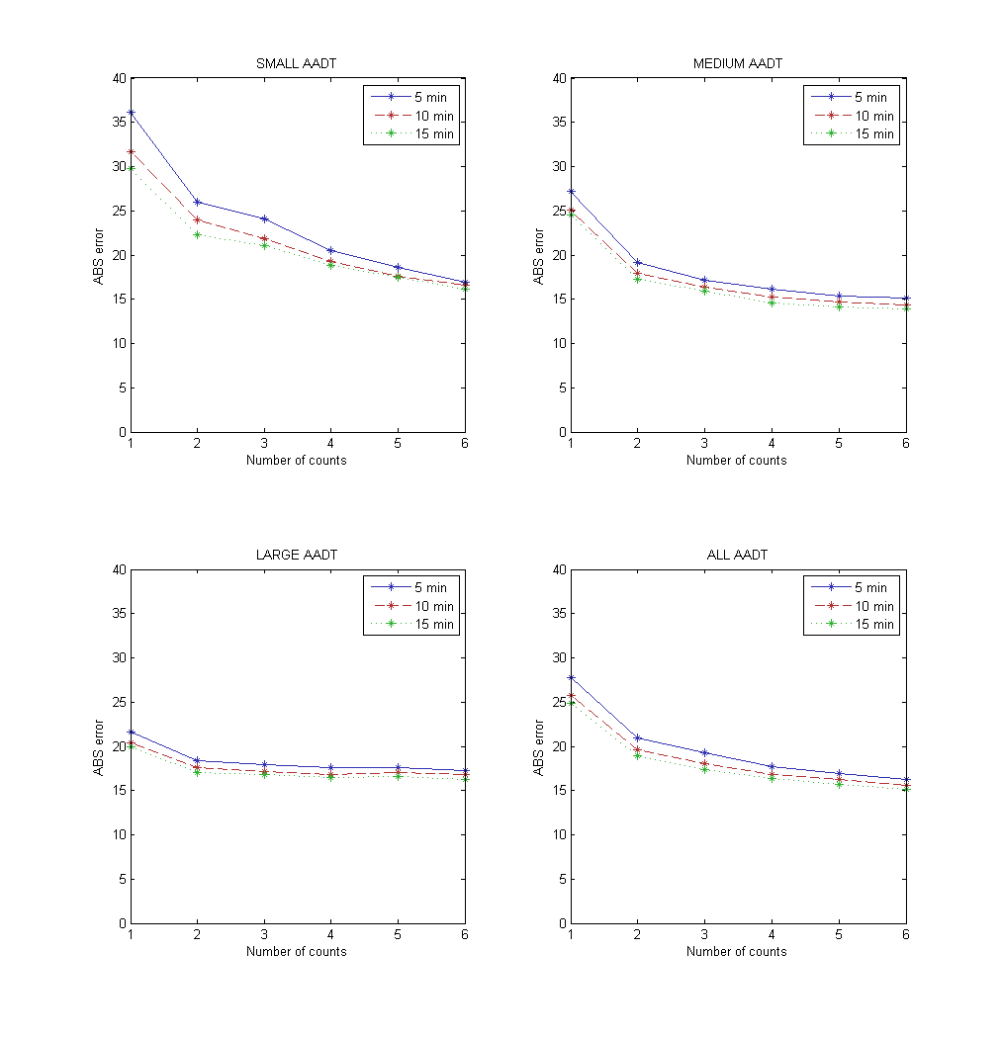
Figure 2. Average absolute error of the AADT estimate.

five examples of counting stations with large AADT values. However, the perhaps most important result shown by these experiments is that the method is stable; even with only five minutes of data, the AADT estimate does not get totally out of proportion. As mentioned above, in many roads, the alternative is no AADT estimate at all, since ground-based measurements are too expensive. The information from two to three satellite images would then be valuable, even if it comes with a relatively high uncertainty measure.

- CONCLUSIONS

We have presented a method for automatic vehicle detection in QuickBird images, with special focus on Norwegian road conditions, i.e., narrow two-lane roads with relatively low traffic density, and challenging conditions related to tree shadows entering the road. The detection algorithm consists of a segmentation step followed by feature extraction and classification. The segmentation, which is based on morphological operations followed by Otsu threshold selection, is performed in very local sub regions of the image, and the results are combined to generate the final result. For classification, the 5-KNNC method was applied to bright and dark segments separately, and using two classes. The algorithm was tested on 31 sub images from five different QuickBird images of various non-urban locations in Norway. The detection rate, i.e., the number of correctly detected vehicles compared to all vehicles, was 92%, and the false alarm rate, i.e., the number of false detections with respect to the number of vehicles, was 11%.

The motivation behind this study is the need for more reliable estimates of traffic density, usually represented by the AADT
parameter. This information is used as input to estimation models

for traffic noise and air pollution, and it is crucial for successful planning, maintenance and construction related to the road network. According to our experiments, assuming 100% correct vehicle detection results are extracted from three different satellite images over the same road within a year, AADT can be estimated with an expected accuracy of 20%. This number depends on various factors; most importantly are perhaps the traffic density, the length of the road segment, and the speed of the vehicles. Ideally, the information from satellite data should be combined with data from ground based equipment, i.e., traditional traffic counting equipment. The necessity of the satellite approach first and foremost lies in its ability to cover large geographical areas, especially roads with low traffic density, which traditionally have not been covered.

REFERENCES

M. Aldrin. “Traffic volume estimation from short-period traffic counts”, Traffic Engineering+Control, 39, p. 656-660, 1998.

P. Burlina, V. Paramerswaran, and R. Chellapa. “Sensitivity analysis and learning strategies for context-based vehicle detection algorithms”, Proc. DARPA Image Understanding Workshop, New Orleans, Louisiana, pp. 577-584, May 1997.

S. Hinz. “Detection of vehicles and vehicle queues for road monitoring using high resolution aerial images”, Proc. 9th World Multiconference on Systemics, Cybernetics and Informatics, Orlando, Florida, unpaginated CD-ROM, 10-13 July 2005.

X. Jin and C. H. Davis. “Vehicle detection from high-resolution satellite imagery using morphological shared-weight neural networks”, Image and Vision Computing, 25(9):1422-1431, 2007.

S. Ø. Larsen, J. Amlien, H. Koren, and R. Solberg. ”Mapping road traffic conditions using high resolution satellite images”, GEOBIA 2008 – Pixels, Objects, Intelligence, Calgary Alberta, Canada, August 5-8, ISPRS Vol. No. XXXVIII-4/C1, Archives ISSN No.: 1682-1777, 2008.

N. Otsu. “A threshold selection method from gray-level histograms”, IEEE Trans. Syst. Man Cyb., 9(1):62-66, 1979.

C. Schlosser, J. Reitberger, and S. Hinz. “Automatic car detection in high resolution urban scenes based on an adaptive 3D-model”, Proc. IEEE/ISPRS joint Workshop on Remote Sensing and Data Fusion over Urban Areas, Berlin, Germany, pp. 167-171, 2003.

G. Sharma, C. J. Merry, P. Goel, and M. McCord. “Vehicle detection in 1-m resolution satellite and airborne imagery”, Int. J. Remote Sensing, 27(4):779-797, 2006.

T. Zhao and R. Nevatia. “Car detection in low resolution aerial images”, Proc. Eight IEEE Int. Conf. Comp. Vision, Vancouver, Canada, pp. 710-717, 9-10 July 2001.

H. Zheng and L. Li. “An artificial immune approach for vehicle detection from high resolution space imagery”, Int. J. Comp. Sci. and Network Security, 7(2):67-72, 2007.

* Corresponding author. ** This research was funded by the Norwegian Public Roads Administration and the Norwegian Space Centre.

