Estimation of time shift in 4D seismic data

Kolbjørnsen, O.¹, Syversveen, A.R.¹

1) Norwegian Computing Center, P.O. Box 114, Blindern, 0314 Oslo

1. Introduction
As a reservoir matures the saturations in the reservoir are changed. Typically gas or brine replaces oil. The seismic response is affected by this trough a time shift because the seismic velocities are altered, and trough amplitudes since the reflection coefficients are altered. That is, both the mapping from depth to time and the amplitude response change between two surveys. While the amplitude changes contain information of intermediate frequency, the time shift contains low frequent information. Estimation of time shift is discussed by e.g. Landrø et al (2001). In this talk we describe an algorithm which estimates the time shift, and propose how to use 4D inversion to further improve the estimate of the timeshift. The time match algorithm is tested on synthetic generated data and on real data from a North Sea field.

2. Algorithm
We have developed a method to extract time shifts from 4D seismic. We consider this a problem of nonlinear pairwise alignment of seismic traces. The problem of nonlinear pairwise alignment of seismic traces is discussed in Liner & Clapp (2004). They formulate the problem as an optimization problem. In this respect our approach is similar to the one by Liner & Clapp (2004). The optimization algorithm and the application we consider is however different.
The algorithm matches the time in a new survey, t_{T}, with the time in the original survey, t₀, i.e. it estimates the time to time map t_{T}(t₀). The algorithm works on a trace by trace basis. The matching is done by compressing and stretching the time axis in order to minimize the squared difference between amplitudes. The optimization algorithm we use is simulated annealing. This is an iterative algorithm. In each iteration a smooth perturbation of the current state is proposed. This new state is accepted or rejected with a probability based on the difference in fit. As the algorithm progresses, the probability of accepting a worse fit tends toward zero. Time match of a whole cube can be very time consuming. In order to save time, we propose to match only a part of the traces, and interpolate over the cube. More details on the algorithm can be found in Kolbjørnsen & Syversveen (2005).

3. Synthetic test case
A synthetic test case was built for testing of the time match algorithm. A synthetic reservoir was constructed in a 2500m·2500m·1200ms large region. The synthetic reservoir is 800ms thick for illustrational purpose. Fluvial channels of sand were generated in a homogeneous background of shale, and zones with only background were placed on top and bottom of the reservoir. We assume that the channels are filled with oil at time 0 and gas at time T. Synthetic reservoir variables Vp, Vs and Rho are generated by Gaussian random fields at time 0 and T . The z-axis is now the time reference at time zero, i.e. t₀. In the cells containing shale, the petrophysical variables are equal at time 0 and T. The time shift introduced by this model is calculated by using the relation:

dt₀/dt_{T} = Vp(gas)/Vp(oil). (1)

The time reference for the second reservoir is then computed and the reservoir variables at time T are shifted to the natural time reference, i.e. t_{T}.
Synthetic seismic for zero offset is generated for both the oil and gas case and this seismic is used for testing the time match algorithm. The seismic is generated using a convolution model. The seismic wavelet was a Ricker wavelet with peak frequency at 30 Hz. The time match algorithm was run on the resulting datasets. The last 40 ms in the cube is kept constant in order to avoid boundary effects. Figure 1 shows true and estimated time shift for the synthetic data.

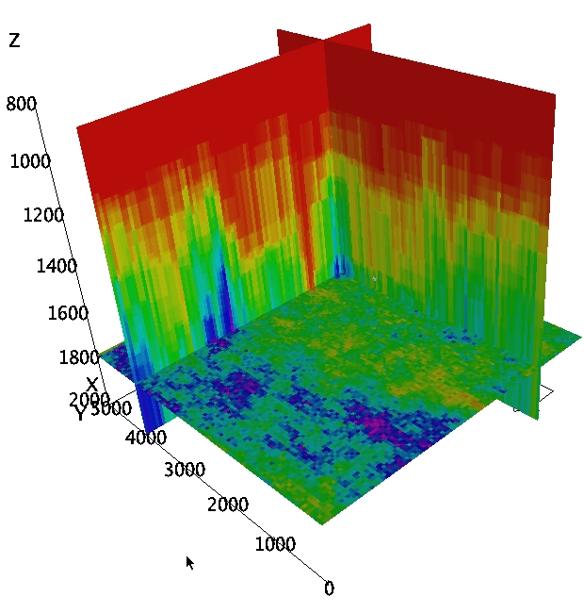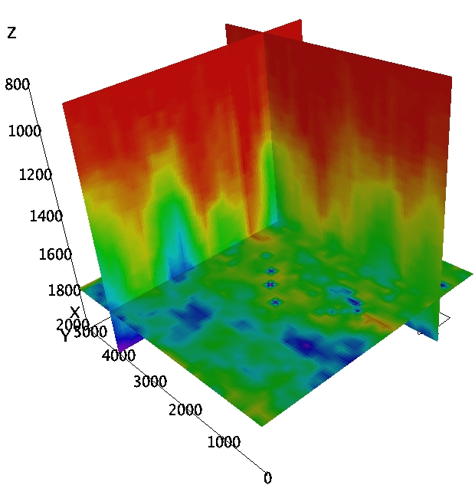
Figure 1: True (left) and estimated (right) time shift.

3.1 Inversion test
The amplitude data include additional information regarding the time shift, since the change in velocity influence both the time map and the reflection coefficients. It is interesting to see if inversion of the seismic improves the estimate. An additional set of far offset cubes is used in the inversion. The inversion is done using the seismic inversion program developed by the Norwegian Computing Center. The theory behind the program is described in Buland et al (2003). The seismic inversion was preformed as two separate 3D inversions, both done in their respective time frames. The background model for the oil case is interpolated between four smoothed vertical wells. The background model for the gas case is adjusted by the estimated time shift according to the formula:

(2) r^{BG}(oil) = r^{BG}(gas) (a· dt₀/dt_{T} )^{b},

where r denote the seismic parameter in question and (a,b) are constants given as (1,1), (1, 0), and (1,1) for Vp, Vs and density respectively.
After the inversion, the results for the gas case are shifted back with the estimated time shift, so the two inversions have a common time reference. The derivative of the time shift is estimated as 1-Vp(gas)/Vp(oil), and the time shift is calculated from its derivative. Figure 2 shows the true and estimated time shift after inversion. Further details about the test case can be found in Kolbjørnsen & Syversveen (2005).

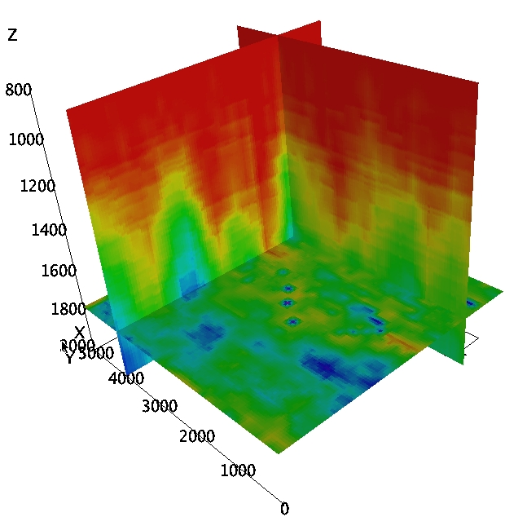
Figure 2: True and estimated time shift estimated from inverted Vp.

4. Time shift of real data
The seismic data available were near and far offset cubes from a North Sea field acquired in with four years lag. We worked with the part of the cubes that is 800ms thick; this region covers most of the reservoir. Figure 3 shows difference between monitor and base, before and after time match.

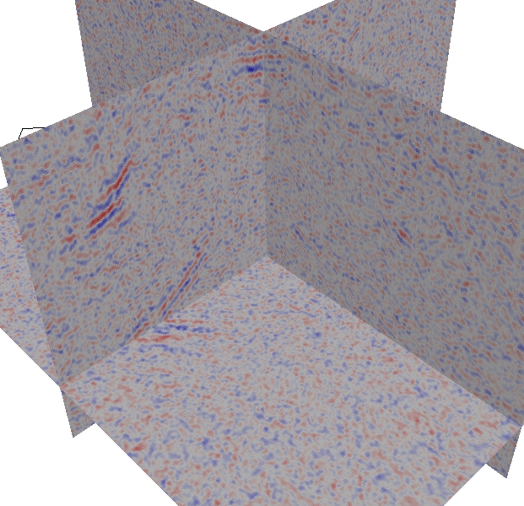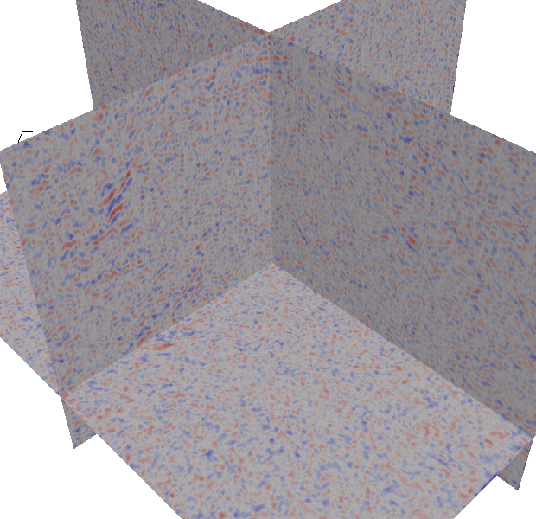
Figure 3: Amplitude of residuals, full offset data. Left: before time match, right: after time match.
In the figure one see that much of the high amplitudes on the left side are removed, whereas the general noise in the difference remains the same in both cases. The variance of the difference is reduced by 8%. This indicates that the method does not overfit the time match. The time shift operation does not change the nature of the signal significantly, compare the monitor survey with the shifted version, see Figure 4.

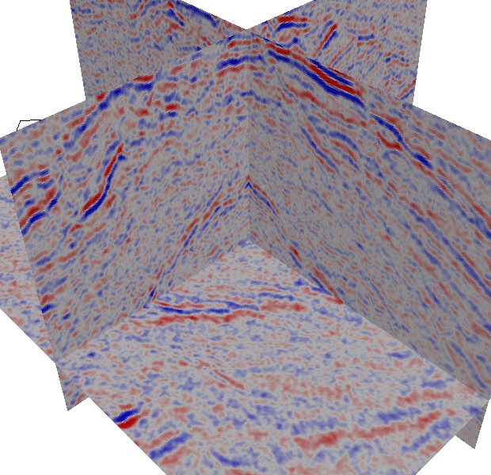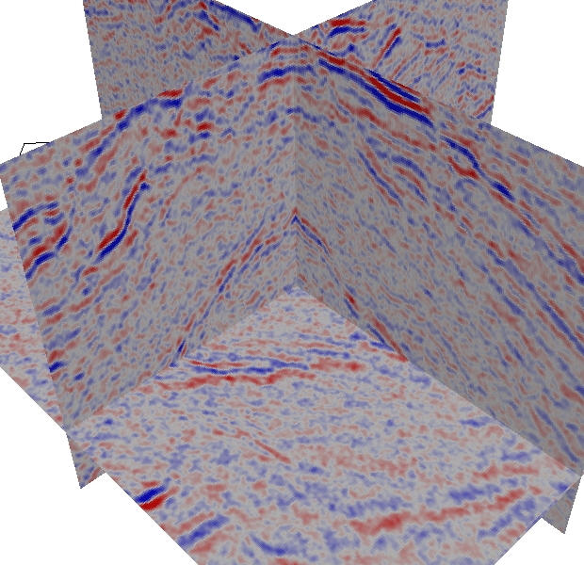
Figure 4: Monitor survey (left) and shifted monitor survey (right)
The estimated time shift and its derivative is displayed in Figure 5. The derivative cube indicates where the velocity changes have occurred, which again indicate where oil is replaced by gas.

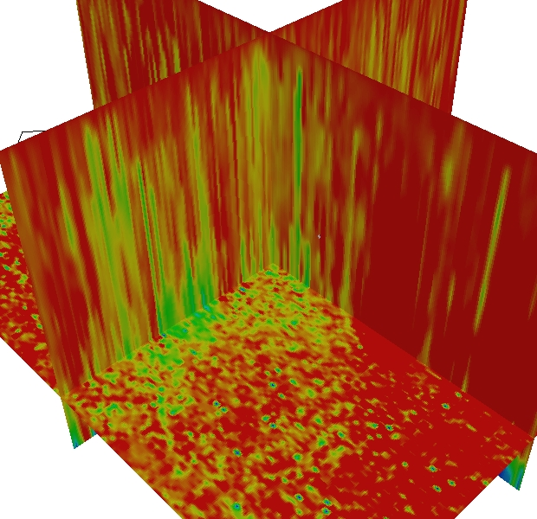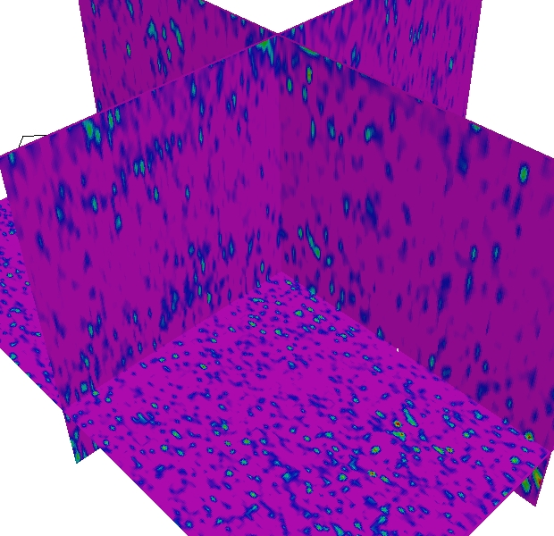
Figure 5: Time shift (left) and its derivative (right)
The red color indicates no time shift. The maximum time shift given by the light green color in the current section is about 5ms. The pink color indicates no local velocity change, whereas the blue and green color indicates decay in the velocity, with the green color being about 5 % decrease in the velocity. Note in particular the continuous feature at the top left of the derivative cube, which could indicate a layer with large changes. The zones of large changes show good correspondence with regions witch are flooded with gas.

5. Concluding remarks
We have developed a method for estimating time shift and show how to include amplitude data to improve the estimate further. The method can also be used to define a background model for the change of seismic parameters as a part of a 4D inversion procedure when large or moderate time shifts occurs. The time match algorithm performs well on the test case and the estimate is improved by using amplitude data. On the real data the method reduces the high amplitudes in the difference cubes and the time shifts is consistent with other sources of information.

6. References
Buland, A., Kolbjørnsen, O. & Omre H. 2003: Rapid spatially coupled AVO inversion in the Fourier domain. Geophysics, Volume 68, Issue 3, pp. 824-836.
Kolbjørnsen, O. & Syversveen, A.R. 2005: Time match – a method for estimating 4D time shift. NR note SAND/03/05.
Landrø, M, Digranes, P. & Strønen, L.K. 2001: Mapping reservoir pressure and saturation changes using seismic methods – possibilities and limitations. First Break Volume 19.
Liner, C.L. & Clapp R.G. 2004: Nonlinear pairwise alignment of seismic traces. Geophysics, Volume 69, Issue 6, pp. 1552-1559.

